Community Rugby Coach

Dear All,
My name is Mark Sinclair, I am 16 years old and was formerly a pupil of Stromness Academy. For many years I have had a high interest in rugby as I have played the game since I was in P1 and am now going into my first year at U18 level.
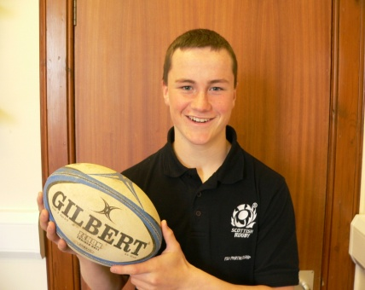
I am now the new apprentice for Orkney RFC and will be working with Bruce Ruthven as a Community Rugby Coach. My course will be partly sponsored by the Orkney Rugby Club and the other part by the SRU (Scottish Rugby Union). The programme is a management level 2 course and will last for 1 year. Through year one I will be assisting Bruce with teaching and coaching Tag rugby within many schools and at the rugby club on Saturdays. As well as helping around the local community I will also be travelling south to complete my portfolio at Murrayfield.
I hope I can achieve a high outcome in coaching rugby within the schools that can then help me advance into sporting/rugby development. I look forward to meeting you all around the schools in the near future.
Yours sincerely,
Mark Sinclair
Email: markpuckle@hotmail.co.uk
Telephone: 07901363532

